LOCAL AVIATION MEDICAL EXAMINERS

Here is a list of qualified Aviation Medical Examiners (AME):

- Dr. Lars Hans Hertzog 5094 E. Los Coyotes Diagonal, Long Beach 562-426-1773
- Dr. Arnold J. Brender 17742 Beach Blvd #215, Huntington Beach 714-848-1655
- Dr. Frederic S. Bongard 21840 S. Normandie Ave #700, Torrance 310-222-5189
- Dr. James Deutsch 2382 Crenshaw Blvd, Torrance 310-618-9200
- Dr. Andrew Lindsay Morrison 2720 North Harbor Blvd #100, Fullerton 714-449-6900

You may also visit the website below to locate an Aviation Medical Examiner (AME) near you.

http://www.faa.gov/pilots/amelocator/
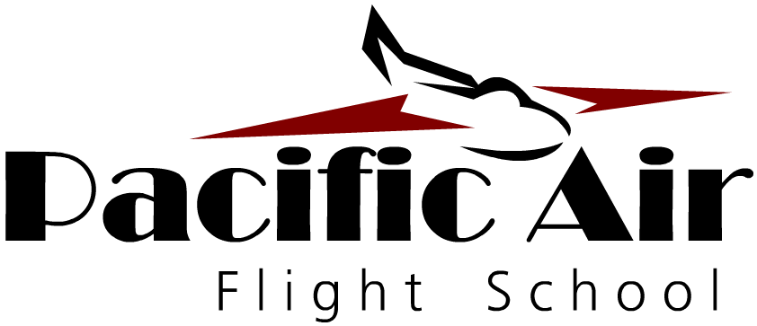

IMPORTANT:

New students must apply for a
“THIRD* CLASS MEDICAL CERTIFICATE” and “STUDENT PILOT CERTIFICATE.”
(You will receive 2 certificates in 1)

*Third class is the standard for new pilots. Second and First class are for those looking at aviation as a career.

Prior to your appointment with an AME, you must register and fill out an application at:

https://medxpress.faa.gov/

